Alex Mekovsky
COSC 320
Enyue Lu
4/23/2023
Lab 09 Report
Lab Report: I have successfully completed all parts of the lab. I implemented the graphA.dat file in the format as highlighted in the lab file. Below is the .dat file and the output of my code.
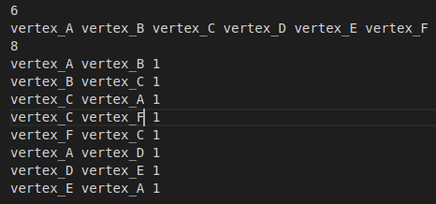

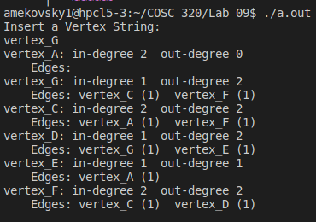
Overall the lab took be around two hours to successfully complete. My biggest issue was importing the graphA.dat file into the code, however with some help and research, I was able to successfully import the graph’s format into the code and make the necessary additions and changes to the graph. I had no issues inserting the new vertex and adding the edges that go along with it.

